FHR Integrated Research Project (IRP-2) Workshop 2
FHR Benchmark Workshop
Draft Workshop Agenda
Clark Kerr Campus, Building 14
Berkeley, California
April 14-15, 2016

Day 0: Wednesday, April 13, 2016 (On Campus, Etcheverry Hall)

1:00 – 2:00 Student/Post-Doc Meet-and-Greet: Welcome to UCB
4118 Etcheverry Hall (TH Lab)
Hosts: Harry Andreades: (703) 474-4215
James Kendrick: (972) 978-1671

2:00 – 2:50 Facilitators’ Workshop Planning Meeting: Logistics
1106 Etcheverry Hall

2:50 – 3:00 Break

3:00 – 5:00 Berkeley Lab Tours (XPREX, CIET, Materials)
Starting from 4118 Etcheverry Hall

5:00 – 6:00 Berkeley Campus Tour
Starting from 4118 Etcheverry Hall

6:00 – 9:00 Reception
3110 Etcheverry Hall

Day 1: Thursday, April 14, 2016 (Clark Kerr Campus)

ALL PARTICIPANTS

8:00 – 8:30 Continental Breakfast
Joseph Wood Krutch Theater

8:30 – 8:45 Welcome and Participant Introduction
Per Peterson (UCB)

8:45 – 9:15 Status of U.S. and International FHR Development Activities
David Holcomb (ORNL)

9:15 – 9:45 FHR MIT-IRP Overview
Charles Forsberg (MIT), Per Peterson (UCB)

9:45 – 10:15 FHR GT-IRP Overview
Farzad Rahnema (GT)

10:15 – 10:30 Break

10:30 – 10:40 Previous Workshop Summary and Workshop Objectives
Per Peterson (UCB)

BREAKOUT SESSIONS
Breakout sessions will consist of meetings in separate rooms/areas for each of the three FHR IRP working groups. Discussion will focus on the working group’s FHR-specific phenomena and relevant benchmarking exercises and progress. The FHR IRP working groups are as follows:
- Neutronics: Meet in Newell Perry Room.
- Thermal Hydraulics: Meet in Krutch Theater.
- Materials, Activation, Tritium, and Transport (MATT): Meet in Clark Kerr Room.

10:40 – 12:00 Session 1: Individual Working Group Session
Discussion of working group’s objectives during workshop, definition of scope

12:00 – 1:15 Lunch
Lunch Talk: SINAP TMSR program update

1:15 – 5:00 Individual Working Group Sessions
Each working group continues discussion

5:00 Adjourn

6:00 Workshop Banquet
Clark Kerr Campus

Day 2: Friday, April 15, 2016 (Clark Kerr Campus)

ALL PARTICIPANTS

8:00 – 8:30 Continental Breakfast
Joseph Wood Krutch Theater

8:30 – 9:00 Summary of Workshop Progress and Overview of Day 2
Working Group Chairs

BREAKOUT SESSIONS

9:00 – 11:00 Resume Working Group Sessions
Each working group resumes previous day’s discussion

ALL PARTICIPANTS

11:00 – 11:15 Working Groups Reconvene

11:15 – 11:30 Working Group Progress Overview: Thermal Hydraulics
Presented by James Kendrick and Charalampos Andreades (UCB)

11:30 – 11:45 Working Group Progress Overview: Neutronics
Presented by Lance Maul and Dan Shen (UCB)

11:45 – 12:00 Working Group Progress Overview: Materials, Activation, Tritium Transport
Presented by Nisarg Patel and Francesco Carotti (UW)

12:00 – 1:15 Lunch
Lunch Talk: “TerraPower: Innovation, TWRs, and Salt” by Robert Petroski

1:15 – 3:15 Multiphysics Discussion – All WGs
Facilitated by April Novak, Xin Wang (UCB), Nisarg Patel and Francesco Carotti (UW)

3:15 – 3:30 Break

3:30 – 4:00 Issues and implications for fluid fuel technologies
Facilitated by Manuele Aufiero (UCB) and Boris Hombourger (PSI)

4:00 – 4:15 Concluding Remarks and Next Steps
Charles Forsberg (MIT), Per Peterson (UCB)

4:15 Adjourn

All workshop participants should prepare for the possibility of light rain on either day. An umbrella and possibly a light rain jacket might be useful items to have.

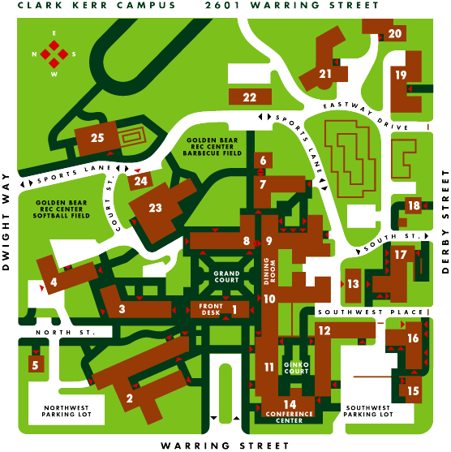

BUILDING 14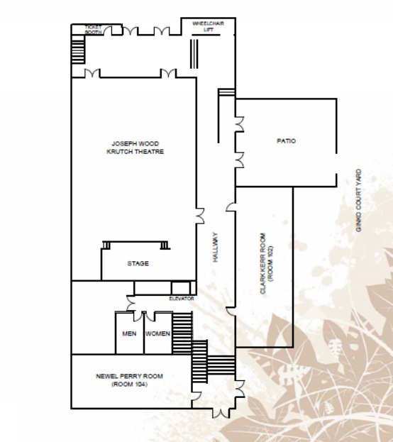
MATT WG
Neutronics WG
General Meeting/
Thermal Hydraulics WG

